2016春季学期语言实践(5月) Language Excursion for MAY
青岛四日游 Qingdao 4-Day Tour
5.5 | 下午14:00东华大学校内集合（松江校区学生出发时间、地点另行通知），乘车前往上海虹桥火车站乘G234次高铁前往青岛。抵达后，入住酒店。 (全天无餐，晚餐自理)  Gather at Yan’an campus before 14:00 pm (Songjiang: departure time & place will be announced later).  Take bus to Shanghai Hongqiao Railway Station and take No. G234 train to Qingdao. Check in. (No meals provided, please prepare by yourself.) |  |   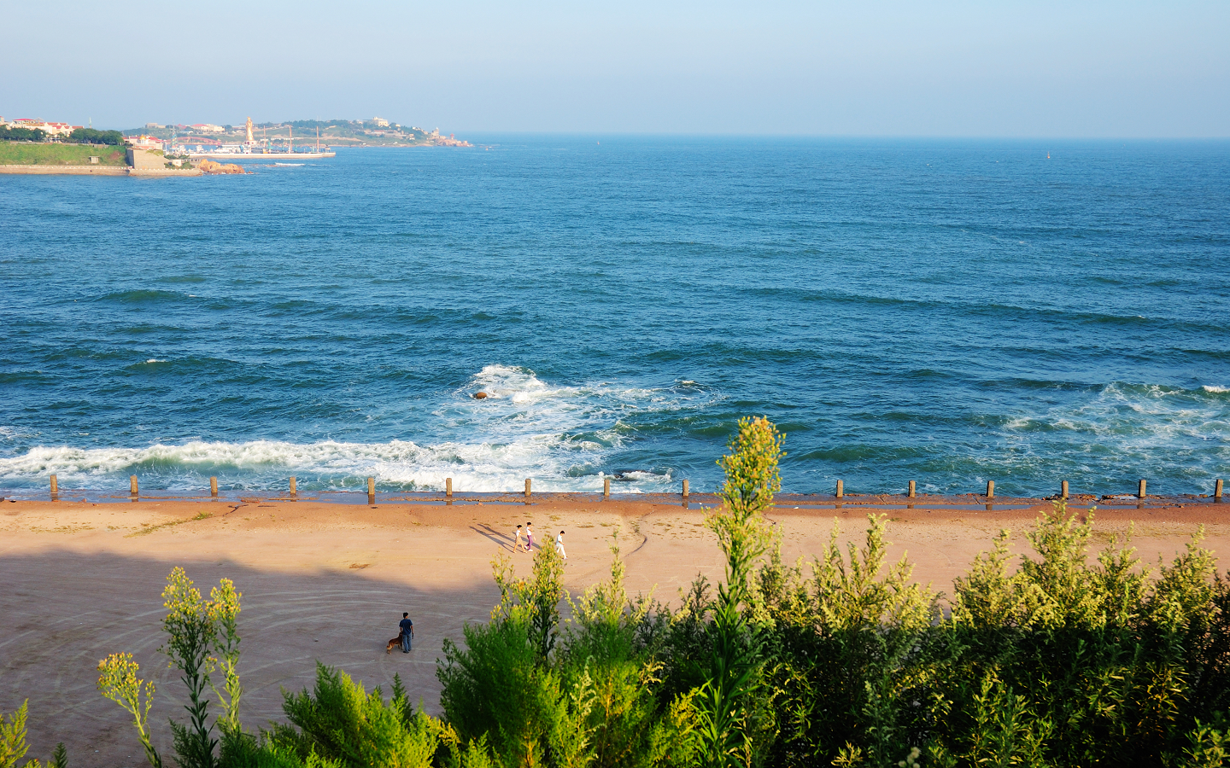
5.6 | 早餐后，攀登崂山太清宫风景区。午餐后，随后游览东海路雕塑一条街、石老人黄金海岸自由活动。游览青岛新城市的标志—五四广场、音乐广场。(含早餐、中餐)  After breakfast, visit Taiqing Temple of Laoshan;  After lunch(free time), enjoy art street of sculpture in Donghai Road and visit Gold Coast in Shilaoren tourist resort; visit the new landmark of Qingdao—May-Fourth and Music Square. (Breakfast & lunch included in fee)
5.7 | 早餐后，游览青岛的百年标志—栈桥。午餐后，游览爱情庄园、万国建筑博览园---八大关 。(含早餐、中餐)  After breakfast, visit the historic landmark of Qingdao—Trestle Bridge;  After lunch, visit the Love Manor and the Architecture Expo Park—Badaguan (Breakfast & dinner included in fee).
5.8 | 早餐后，参观青岛啤酒博物馆。午餐后，乘G228次高铁返回上海。(含早餐、中餐)  After breakfast, visit Qingdao Beer Museum;  After lunch, take No.G228 train back to Shanghai. (Breakfast & lunch included in fee)
学生类别 Student Types |  | 费用 Fee
语言生 Language Students |  | 1800 RMB
专业生（含公费生和自费生）  Degree Students and Degree Scholarship Students |  | 800 RMB
学生家属Students’Family Members |  | 2000 RMB
报名方式 (Registration)：网上报名 (Register online): http://apply.ices.cn/
网上报名步骤请见学院官方网站 http://ices.dhu.edu.cn/ (通知公告栏)
For more information on how to register online visit http://english.dhu.edu.cn/ (Notice and Coming Events section)
网上报名时间：3月28日-3月31日 Registration Time: 28 March- 31 March
注意事项 (Note)：
1、本次旅行预计共有4辆大巴车，报名时请注意车辆编号。延安路校区的同学请选择1号-3号，松江的同学请选“松江大巴”。
There are estimated 4 buses. While registering please mention the Bus No. you wish to be on (Yan’an Campus: No1-No3; Songjiang: Songjiang Bus).
2、名额有限，先到先得，欲报从速！ Limited seats. First come, first serve.
3、网上报名后请在4月5日-4月7日到国际文化交流学院107办公室崔老师处付费，付费后方可算报名成功。
To complete registration: please go to ICES Office 107 from 5th April to 7th April to pay registration fee with Cui Laoshi.
4、所有线路报名付费后不能退款。 All Registration Fee is non refundable
5、已成功报名的学生如无故缺席此次语言实践活动，将取消明年参与此类活动的资格。
For students who already signed up : Unexcused absence will lead to disqualification from language excursion for next year.

